Web Network Load Balancer (WNLB)
Software Requirements Specification

Version 1.0



Supervisor Name: Tanweer Arshad
Student Name: Faheemullah Memon
Student ID: MC070402736

Revision History

Date (dd/mm/yyyy) | Version | Description | Author
22/11/2012 | 0.1 | Initial draft | Mc070402736
25/11/2012 | 1.0 | Finished and reviewed | Mc070402736

Table of Contents
Revision History 2
1. Introduction 4
1.1 About this document 4
1.2 The Project 4
1.2 Project Scope 5
1.3 Deliverables 5
1.4 Timelines 6
1.5 Implementation limitations 6
2. Functional and Non-Functional Requirements: 7
2.1 Functional Requirements 7
2.1.1. Configuration wizard 7
2.1.2. Intercept and off-load incoming requests to available least busy servers 7
2.1.3. Provide a web-based configuration and monitoring interface 7
2.1.4. Health checking and failover 7
2.1.5. Logging 8
2.1.6. Diagnostics / Crash Collection 8
2.1.7. Session stickiness 8
2.2. Non-functional requirements 8
2.2.1. Robustness 8
2.2.2. Scalability 9
2.2.3. Security 9
2.2.4. Performance 9
2.2.5. Usability 9
3. Use Case Diagram(s): 10
3.1. Basic Use Case 10
3.1.1. Diagram 10
3.1.2 Description 10
3.2. Extended Use Case 11
3.2.1. Diagram 11
3.2.2. Description 11
3.3. System Configuration 12
3.3.1 Diagram 12
3.3.2. Description 12

1. Introduction

1.1 About this document

This is a software requirements specification document for project Load Balancing of Network Traffic. The document goes over the software requirements from high-level to detailed user interaction scenarios.

1.2 The Project

In 1989, Sir Tim Berners-Lee, a British scientist wrote a proposal regarding a way of sharing information with the help of cross-referenced documents spread across the world accessible via internet, which eventually came to be known as World Wide Web. World Wide Web (or called the web for short) took off and quickly became a viable way of sharing information. Information was first shared in form of text and pictures, sound and video soon followed. A set of documents, called web pages, written in a simple markup language, HyperText Markup Language, delivered these resources to the interested audience. These web pages were stored on a machine dubbed web server and were made available on Internet with help of grand network hardware infrastructure and series of networking protocols, predominantly TCP/IP. The person who wanted to access this information used client software called web-browser.

As the web became more and more accessible more information was being shared. This put a strain on both network infrastructure and web servers. The network infrastructure not scaled out for the given volume of data traffic resulted in limited network bandwidth and slower Internet connection or less accessibility. Web pages that contained multi-media elements were slower to load and respond. Still today and in even for foreseeable future Web servers remain in mode of constant hardware and software upgrades.

Although network bandwidth problem is dependent on hardware used in the network infrastructure, web servers can respond faster with help of specialized load balancing software programs. This project is a network load balancer that supports asymmetric clustering model. In a typical asymmetric model one entity is considered pivot or master that distributes traffic load across the connected slave entities.

1.2 Project Scope

As described in latter section, in face of ever increasing web traffic network load balancers are inevitable. This project takes on challenge of implementing a web based network load balancer using .NET technologies. It will run on top of Internet Information Server, a web server implementation from Microsoft Corp. It will work as a smart conduit and distribute incoming requests among configured web servers to balance the load across server cluster. Stating broadly, it will follow asymmetric model for load balancing. At a higher level it will support following core functions:

- Accept HTTP based web requests from users and route them to configured resource servers
- Handle potentially large volume of web traffic
- Provide network monitoring and reporting services for system administrators
- Provide failover support and automatically remove defective servers from pool
- Support session affinity/stickiness for subsequent user requests to allow proper session management.

1.3 Deliverables

This software project and related documentation will be submitted for final project, a requirement for completing Master of Information Technology (MIT) degree at Virtual University of Pakistan. All documents, source code, and binaries will be owned and distributed according to guidelines of Virtual University of Pakistan. This project will contain following artifacts.

- Software Requirements documents
- Software architecture and design documents
- Source codes - .NET and IIS compatible
- Executable binaries and optionally installers

1.4 Timelines

Complete software application along with documentation will be developed in the period specified by Virtual University and which is normally in a year’s time. Deliverables will be produced and submitted as directed by supervisor.

1.5 Implementation limitations

Since this is an academic project, it will not contain all features of a typical COTS network load balancing software. More complicated implementation components will be skipped in favor of timeline and simplicity. However, it will implement core components of a network load balancer as suggested in project scope. For an example following features will not be supported:

- HTTP Caching
- HTTP Security
- TLS/SSL support
- DDoS protection
- TCP/IP based offloading
- TCP buffering

2. Functional and Non-Functional Requirements:

2.1 Functional Requirements

2.1.1. Configuration wizard

System will provide a configuration wizard to simplify configuration. This wizard will be launched the first time after system is setup. It will allow configurator to:
- Setup admin username and password for the system
- Enter available web servers in the pool
- Specify session stickiness settings
- And setup logging and diagnostic options

2.1.2. Intercept and off-load incoming requests to available least busy servers

System will intercept all incoming web requests for the cluster. It will run on top of Microsoft Internet Information Server and face the incoming traffic. It will off-load incoming traffic to available least busy server. It will keep track of activity on individual servers with help of health check service.

2.1.3. Provide a web-based configuration and monitoring interface

System configuration should be available via a web interface to enable remote administration. Interface will be password protected. It will allow users to do following set of operations.

- Monitor status of current network configuration
- Update current network configuration
- Generate logging and diagnostic reports
- Change system configuration

2.1.4. Health checking and failover

There will be a health reporting service responsible for keeping check on system activity. All slave machines will report their health and status the master. Master will use that information for off-loading and fail-overs.

2.1.5. Logging

System will log major event that will include both error and success conditions. It will provide a way to configure and control the amount logs generated by the system. System admin should be able to access the logs.

2.1.6. Diagnostics / Crash Collection

System will capture all errors generated. It will allow configuration and control over the amount of diagnostic information generated. Optionally it will provide GUI based interface to look at the error reports for system administrators or provide email admin functionality.

2.1.7. Session stickiness

System will provide an option to turn on or off the session stickiness feature. This is an essential feature for dynamic applications that use sessions to keep track of user interaction for multiple HTTP requests. With this option enabled users will be directed to same slave server for subsequent requests. Other high level frameworks on slave machines will handle session management.

2.2. Non-functional requirements

2.2.1. Robustness

Since this is going to be a critical piece of software it should be a very important feature of this software to maintain certain level or robustness and fault tolerance. At the very basic level it should provide fail-over support. If a slave server fails down it should be removed from the pool and subsequent requests will not be forwarded towards it. System should report selected system administrator of the failure via email messages. In case all the servers were down system will provide a friendly message to the end users and support graceful failure strategy.

2.2.2. Scalability

Scalability is an essential aspect of this system. It will allow system admin to add slave servers to the system as desired. The number of slave server will be limited mostly by the hardware limitations. Core footprint of the system will be very little depending on the configuration settings done.

2.2.3. Security

System will support security options provided by HTTP protocol. It will allow SSL and TLS based message transmission encryption. It will support all SASL authentication mechanisms for user authentication.

2.2.4. Performance

Sole purpose of this software is to achieve better performance by load balancing. System will be efficient in routing requests and increase performance for subsequent requests from the users.

2.2.5. Usability

A rather un-friendlier side of the system software is that they are hard to use, configure, and diagnose. This system will handle these problems and take a user-friendly approach to usage, configuration and diagnostics. System configuration wizard, GUI based error-reporting system, remote system administration will be some of the features that help with usability of the system.

3. Use Case Diagram(s):

3.1. Basic Use Case

3.1.1. Diagram
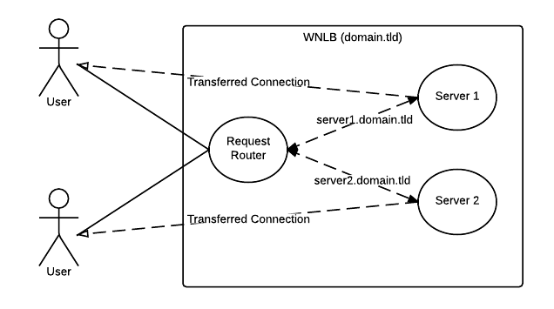
Figure 1

3.1.2 Description

The diagram demonstrate very high-level requirement of the system. When a user sends the request to the load balancer, it redirects the call to available server. Available server responds to the user with desired resources. After the basic selection and depending on system configuration, subsequent requests will be direct between user and the resource server. This diagram also shows session stickiness concept.

3.2. Extended Use Case

3.2.1. Diagram
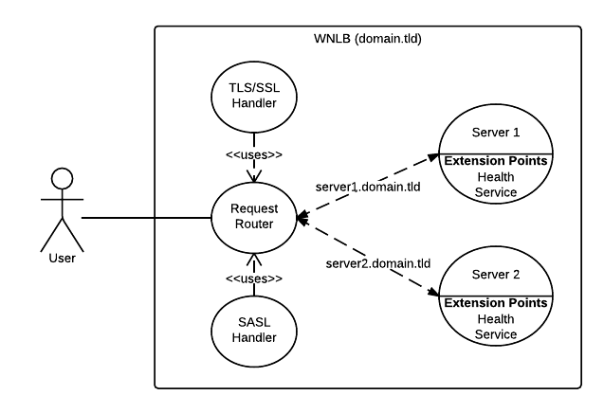Figure 2

3.2.2. Description

This diagram shows session-less approach. Every request passes through the request router and is secured behind a certificate and an authentication mechanism. There is a part of the resource server that represents the health service, which report system stats and health data back to the server.

3.3. System Configuration

3.3.1 Diagram
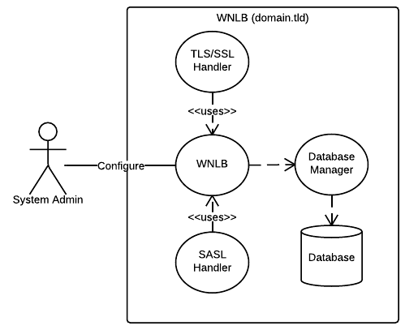
Figure 3

3.3.2. Description

This is a basic diagram showing system admin user changing system configuration. System configuration will be saved in permanent storage. Storage can be database or an XML configuration file depending on available options.
4. Usage Scenarios:

Use Case Title | Configuring System for the first time
Abbreviated Title | Config Wizard
Use Case Id | 01
Requirement Id | 2.1.1.
Description: System administrator sets up the hardware configuration of the system and install the core software on master system. After installation, he/she browses the installed software in a local web browser on that machine and a configuration wizard starts off. Configuration wizard will help system admin setup the software and kick-start the web network load balancer.

Pre Conditions:
- Hardware configuration is all set
- Slave software are installed on slave machines and ready to be integrated
- Master software and it’s pre-requisites are installed on the master machine
- System admin opens up the browser and enters the software URL in browser of choice.
Task Sequence |  | Exceptions
- System admin enters the URL in the browser and password page loads up |  | Software not installed properly or wrong URL entered. An error page shows up with relevant diagnostics information.
- Admin enters the password of choice, confirms it and moves to the next screen |  | Error shows if password complexity requirements are not met or confirmation fails.  NOTE: This step won’t trigger if it was performed previously and wizard was abandoned, instead regular login page will kick in and wizard will resume to next step.
- Admin enters the client machine addresses and system preforms connectivity check. System proceeds to next step. |  | System fails to connect with client machines. Admin is prompted to check the state of machine and re-enter the addresses.  NOTE: This step will proceed automatically and check the connectivity status of slave machines if wizard was abandoned halfway through in previous sessions.
4. Admin enters session stickiness settings and system proceeds to next step |  | Step will be repeated if already performed in any previously abandoned sessions.
5. System lands to home page.
Post Conditions:
- System will be ready to take user requests and distribute amongst the slave machines.
- System will be ready for remote administration
Unresolved issues:
Authority: Administrator
Modification history:
Author:
Description:

Use Case Title | Remote Administration
Abbreviated Title | Remote Administration
Use Case Id | 02
Requirement Id | 2.1.3.
Description: System administrator logs into the system from a remote machine over intranet or Internet. After successful login, admin is taken to the home page. Home page displays current state of the system and way to navigate to the other sections of the system.

Pre Conditions:
1. System was configured previously and admin logs in successfully in the system.
Task Sequence |  | Exceptions
- System admin enters the URL in the browser and login page loads up |  | Software not installed properly or wrong URL entered. An error page shows up with relevant diagnostics information.
- Admin enters the pre-set password and hits a login button. |  | System shows error in case of wrong password entered.
- Admin is taken to the home page of system. On home page admin looks at the system state and has navigation links to get to other sections of the console.
Post Conditions:

Unresolved issues:
Authority: Administrator
Modification history:
Author:
Description:

Use Case Title | Viewing System Logs
Abbreviated Title | Logs
Use Case Id | 03
Requirement Id | 2.1.5.
Description: In case of any issues with the software system, System administrator checks out the logs folder for details. Logging file location and other configuration settings are available through editable configuration file on the system locally. These settings are not available from web-based console.

Pre Conditions:
1. System was configured previously and admin has access to the machine.
Task Sequence |  | Exceptions
- System admin logs into the web console and checks out the physical location of the logs files. |  | Software not installed properly or wrong URL entered. An error page shows up with relevant diagnostics information.
- System admin gets access to the machine OS and opens up the logs folder |  | System admin doesn’t have the access to the OS to get to the log folders
- Logs files are available for viewing, archiving, exporting, or any other required operation.
Post Conditions:

Unresolved issues:
Authority: Administrator
Modification history:
Author:
Description:

Use Case Title | Viewing Crash Reports and Other Diagnostics Information
Abbreviated Title | Crash Reports
Use Case Id | 04
Requirement Id | 2.1.6.
Description: There will be multiple outlets to view system crash reports and diagnostics information. A remote and password protected web interface will be provided along with log files generated on system machine. Web based interface will be available from home page of web-console.

Pre Conditions:
1. System was configured previously and admin has access to the machine.
Task Sequence |  | Exceptions
- System admin logs into the web console and checks out both physical location of the logs files and a link to the web based reports. For accessing logs from OS check out use case scenario 03. |  | Software not installed properly or wrong URL entered. An error page shows up with relevant diagnostics information.
- System admin browses the URL for viewing diagnostic and crash reports.
- System admin views the reports and be able to export data in multiple formats.
Post Conditions:
1. View and export crash reports and other diagnostics information.
Unresolved issues:
Authority: Administrator
Modification history:
Author:
Description:

Use Case Title | Change Administrator Password (Soft Reset)
Abbreviated Title | Change Password
Use Case Id | 05
Requirement Id | 2.1.3.
Description: System admin will be able to change admin password from web console.
Pre Conditions:
1. System was configured previously and admin has access to the machine.
Task Sequence |  | Exceptions
- System admin logs into the web console with current credentials. |  | Software not installed properly or wrong URL entered. An error page shows up with relevant diagnostics information.
- System admin browses to the change password page from home page
- System admin enters the old password, new password, and confirms the new password. |  | A validation error is displayed in case of wrong current password entered or if the confirmation of new password fails.
- A password change confirmation is displayed.
Post Conditions:
1. System admin password for web-console is updated.
Unresolved issues:
- See following use case (06) for hard resets if admin fails to remember the old password.
Authority: Administrator
Modification history:
Author:
Description:

Use Case Title | Reset Administrator Password (Hard Reset)
Abbreviated Title | Reset Password
Use Case Id | 06
Requirement Id | 2.1.3.
Description: In case system admin is unable to recall the old password. They can reset password by clicking forgot password on login page and initiate hard reset process.
Pre Conditions:
1. System was configured previously and admin has access to the machine.
Task Sequence |  | Exceptions
- System admin enters the correct URL of software system on browser of choice. |  | Software not installed properly or wrong URL entered. An error page shows up with relevant diagnostics information.
- System admin hits the forgot password button and en email is sent to the system admin.
- System admin hits on the link available in the email
- A password-reset page is displayed with confirmation field of new password. |  | A validation error is displayed if password confirmation failed or password entered doesn’t satisfy complexity of being over 6 characters long
- A confirmation message is displayed and system admin is redirected to home page.
Post Conditions:
1. System admin password for web-console is reset.
Unresolved issues:
Authority: Administrator
Modification history:
Author:
Description:

Use Case Title | Request Routing
Abbreviated Title | Routing
Use Case Id | 07
Requirement Id | 2.1.2.
Description: A user tries to access the web application from the load-balancing cluster and is served the required content from the least busy server at that given point.
Pre Conditions:
1. System was configured previously and the web application is installed on the slave servers in the cluster.
Task Sequence |  | Exceptions
- User enters the URL of master machine from browser of choice. |  | Software not installed properly or wrong URL entered. An error page shows up with relevant diagnostics information.
- Web server intercept the call, checks the state of slave servers and re-directs the client to least busy server
- Slave server gets the request and serves the client.
Post Conditions:
1. User gets to content desired faster
Unresolved issues:
Authority: NONE
Modification history:
Author:
Description:

Use Case Title | Request Routing with Session Stickiness
Abbreviated Title | Routing Sessions
Use Case Id | 08
Requirement Id | 2.1.7.
Description: A user tries to access the session based web application from the load-balancing cluster and is redirected to the slave server that already holds the previously established session.
Pre Conditions:
- System was configured previously and the web application is installed on the slave servers in the cluster.
- Session stickiness is enabled on the server
- Hosted web application is session based
- A session is already established by the client
Task Sequence |  | Exceptions
- User enters the URL of master machine from browser of choice. |  | Software not installed properly or wrong URL entered. An error page shows up with relevant diagnostics information.
- Web server intercept the call, checks the session cookie in HTTP Request and re-directs the client to respected slave server |  | In case if there is not cookie, system finds the least busy server and assigns that to the session. Creates a cookie and addes to the request for subsequent calls.
- Slave server gets the request, identifies the session, and serves the client.
Post Conditions:
1. User gets to content desired faster and session state is preserved
Unresolved issues:
Authority: NONE
Modification history:
Author:
Description:

